On-Demand Learning Platform
Beta Release Scope
─

About Technogise
About our services
Technogise’s approach to building software
Domains where we have achieved impressive outcomes:
Some of our Clients (ranging from startups to Fortune 300 companies)
Technologies we have expertise in
Vision
The problem we’re tackling
The consumer’s journey
How we keep learners engaged
What Client learns (analytics)
How do people use the app
Which content actually works
Purpose & Rationale
Scope (Mobile App Only)
Timeline, Team, and Cost
Considerations
Assumptions
Out of Scope
Potential Tech Stack
Conclusion

About Technogise
Technogise is a bespoke software development company started in Nov 2015. We serve our global clientele from our delivery centers in Pune and Bangalore, India. Our clients span the spectrum of startups to large enterprises and are major players in the e-commerce, financial services, education & healthcare sectors, among others. Everyone on our team is a poly-skilled full stack developer and together we build the flagship products and services that power our clients' businesses & delight their customers. We are passionate technologists dedicated to solving our clients toughest business problems with innovative and out of the box technology solutions.
You can find more information about the technologies and our work culture in the deck attached in this email. You can find some of the case studies on our website (https://technogise.com/case-studies).

About our services
- Product delivery and CX transformations
  - We build business critical, high volume, web and mobile apps from UX, Dev to DevOps
- Platform modernization
  - Performing tech evolutions, evolving tech strategies

- Product and service line incubation
  - We help our clients in taking an idea from concept to market

- Engineering Evolution and advisory
  - We enable organisation and engineering transformations

Technogise’s approach to building software
- Working software over comprehensive documentation
- Interactions over process/tools
- Collaboration over contract negotiation
- Responding to change over sticking to a plan
While we will do everything on the right, we value all the items on the left a lot more!

Domains where we have achieved impressive outcomes:
- Retail
- Not-for-profits
- Education
- Logistics
- Fintech
- E-commerce
- Gaming

Our clients range from startups to scaleups to large enterprises.

Some of our Clients (ranging from startups to Fortune 300 companies)

Technologies we have expertise in

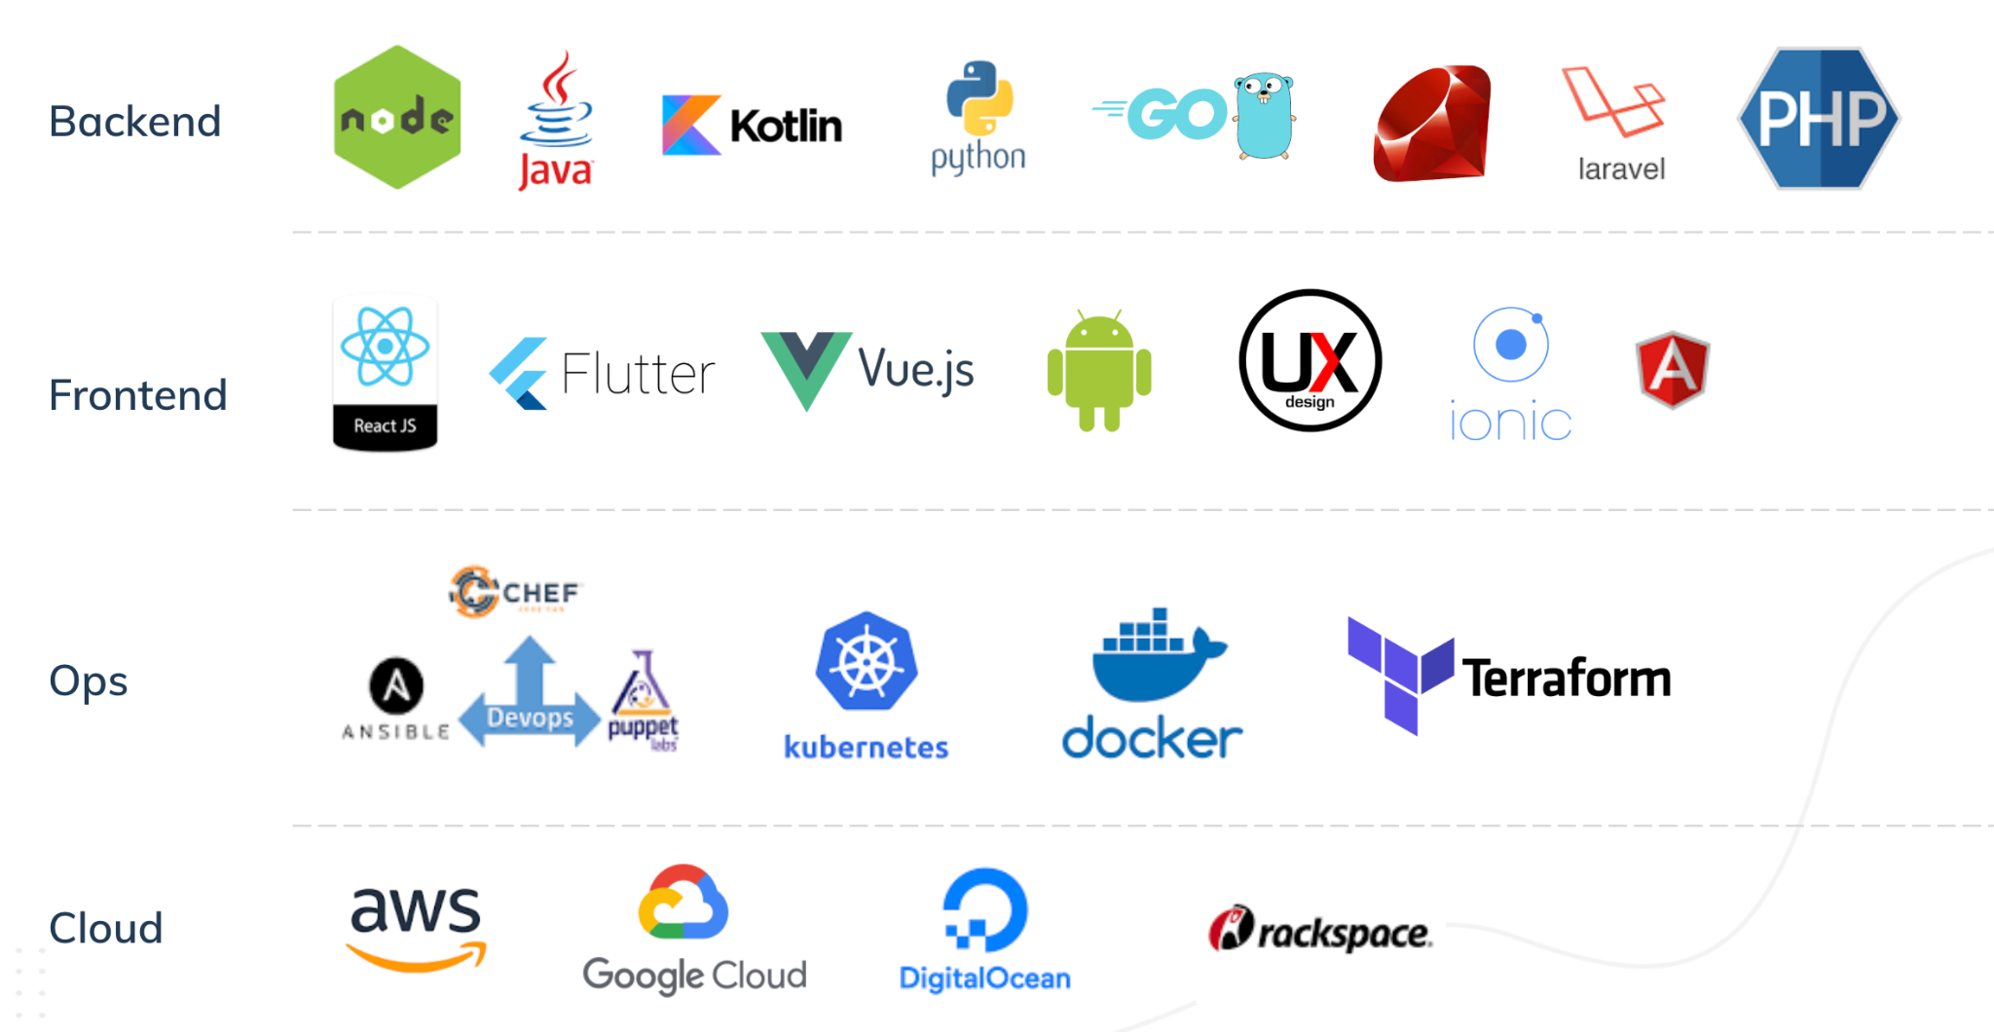
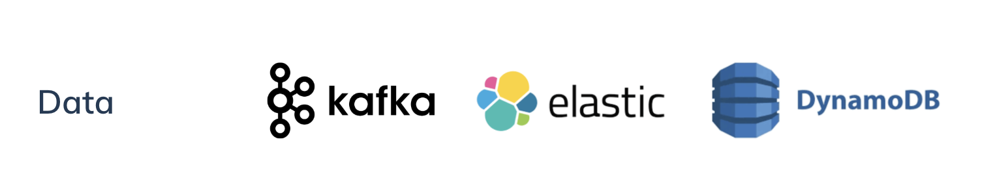

Vision
Client’s on-demand platform aims to become the AI driven OTT of Learning, where users can “learn anytime, anywhere” with personalized recommendations and a vast library of courses, while also earning credible certificates that boost their career prospects.

The problem we’re tackling
Our target audience wants credible, snackable learning that actually leads somewhere. The current gap remains discovery, momentum, and completion. People start, then drop. The Client On-Demand Learning Platform Beta, proves a product that finds the right content quickly, keeps learners moving through a series, and learns what works, before we invest further at scale.

The consumer’s journey
Riya downloads the app recommended by her friend. The sign-up is quick, just her phone/email and she’s in. She picks two interests: Coffee and Productivity.
Her home screen fills itself with a clean, scrollable list of short, snackable learning videos. Each tile clearly shows it’s part of a series. Curious Riya taps on the “Barista Basics” and the first video in the series starts right away. She feels the joy of progress; the app didn’t make her think.
When Episode 1 ends, before she can hesitate, Episode 2 starts automatically. It feels natural, like someone is guiding her forward without asking for effort. Riya smiles; the app is on her side, removing hurdles. A tiny “Was this helpful?” prompt appears. She taps Yes. The app quietly learns and keeps the series front and center. She doesn’t feel pushed.
Halfway through Episode 3 she’s interrupted; the app remembers. Later that evening she reopens the app and lands on “Continue learning” with her place saved. No hunting, no shuffling, no confusion. The app shows a short check-in question (“What milk temperature helps with a heart pattern?”). If she gets it wrong, the next video is a quick refresher; if right, she flows into the next episode. Either way, she feels guided, supported, and a little proud.
By the weekend, Riya has finished the series. The app suggests a follow-on mini-series titled “Milk Textures 101” because people who finish Barista Basics tend to enjoy it. Riya keeps going, not because the app shouts at her, but because it reduces friction, nudges gently, and celebrates small wins. Her emotions through the week: curious → confident → accomplished.

How we keep learners engaged
In Beta, the engagement levers are simple and deliberate; auto-play within series, continue learning where you left off, light check-ins like yes/no prompts or one question quizzes, rule based recommendations based on interests and consumer behaviour, and simple push notifications.
Post Beta, these can expand into complex quizzes and polls, streaks, badges, gamified nudges, personalised content rails, consumer trends, more rule based push notifications.
The Beta thin slice is just enough to prove the viability of the app based on the parameter thresholds to be finalised prior to beginning development.

What Client learns (analytics)
From Riya and her peers (≈100 users), the app quietly records simple, privacy-respecting signals:

How do people use the app
- Do they finish sign-up and pick interests?
- How soon do they play their first video?
- How many videos do they watch per visit, and for how long?
- Do they accept the “Next episode” hand-off or skip away?
- Do they come back to finish a series? Where do they drop?
Decisions this enables: Which entry tiles and interest choices lead to real learning time; whether auto-play and continue learning are strong enough; how long each episode should be to keep people engaged; exactly where to simplify the journey.

Which content actually works
- Which series and categories get watched the most and completed the most?
- Which episode lengths work best (short vs. slightly longer)?
- Do people watch what they said they were interested in, or something else?
Decisions this enables: What to produce more of, what to retire or retag, which follow-on series to recommend, and how to lay out the home screen so more people finish.

Caveat: Based on the effort, in Beta we may export these analytics as simple files/reports; later we can add live dashboards and advanced experiments.

Purpose & Rationale
This Beta scope is the smallest valuable slice to validate the idea and test technical feasibility with ~100 select users. It proves the core loop: content ingestion → interest-based feed → playback → basic recommendations → analytics (with minimal UI and a crude but reliable backend, before investing in scale or advanced features).

Scope (Mobile App Only)
Feature | Effort (Person-Days)
Content Upload - API to upload video | 4
Store content metadata (title, tags, category) | 2
Fetch content list for app from backend | 2
User signup via email address only (for recommendations) | 2
Basic login and session management (managing video history) | 1
Profile setup with minimum required info | 1
Onboarding screen to choose interests | 3
Matching interests with content metadata | 2
Landing page auto-generated feed | 5
Scrollable feed like reels | 5
Video playback integration (Flutter plugin) | 6
Simple rule-based recommendations by tag | 4
Push notification once in 24 hours with simple recommendation | 5
Sequential content suggestion fallback | 2
Capture views and watch duration | 3
Capture skips and completions | 3
Store analytics for approx. 100 users | 2
End-of-video feedback | 3
Store feedback responses | 2
Recommendation adjustment based on feedback | 3
End-to-end integration testing | 5
Bug fixing and buffer | 4
Total | 69 person days

Timeline, Team
- Team: 2 Developers + 1 Product Manager (no dedicated UI/UX designer for Beta)
- Schedule: Between 15-Sep-2025 and 15-Nov-2025 (≈40 working days)
- Target capacity: usable by ~100 users (manageable up to ~200)

Considerations
- Role of the Product Manager:
  - Acts as liaison between stakeholders; turns ideas into clear, testable stories and acceptance criteria for development.
  - Shields developers from context churn, runs daily triage, prioritises a tight Beta backlog, and coordinates a closed user group for fast feedback.
  - Ensures the build stays focused on learning outcomes of the Beta and that feedback rolls into future iterations.
- UI & UX Approach (No Designer in Beta)
  - Simple/auto-generated UI using standard tools and widgets. Advanced UI features are out of scope for Beta.
  - The aim is fast feedback over aesthetics; good enough UI to test engagement and capture data.
- Architecture & Infrastructure (Beta-appropriate)
  - Simple topology, progressive streaming, basic logging, minimal retries; no DRM or multi-CDN
  - Not designed for scale beyond ~100 - 200 users; future enhancements will require refactoring (streaming/CDN strategy, data model, auth hardening, observability, and reliability patterns).

Assumptions
- Client supplies ready content with correct tags; ingestion is best-effort.
- Closed beta distribution to ~100 users.
- No legal/DRM requirements for Beta content; data privacy handled pragmatically (minimal PII, secure storage).
- Success criteria of the product to be determined and scope adjusted to incorporate this accordingly before development begins.

Out of Scope
Below is a list of features that that have not been included in the Beta scope compared to the proposal submitted earlier:
- Overall content management system  - Multiple sign-in methods  - Subscription management  - Payment gateway integration  - Catalogue browse & search UI  - Web video player  - Subscription-based access rules | - Admin analytics dashboard  - Advanced push notifications  - Multi-language UI  - Content generation/creation tools  - DRM, multi-CDN, adaptive ABR tuning  - ML/AI recommendations  - Web/TV/desktop apps | - Certificates, assessments, gamification  - Comprehensive security/compliance hardening  - Scalability beyond ~100–200 users  - Enterprise features  - Polished UI/UX/design system  - Advanced user profile management

Potential Tech Stack
Layer | Technology | Rationale
Mobile Frontend | Flutter / React Native | Native performance (video, offline); wide user base.
Web Frontend | React.js (TypeScript) | Rapid development, Dynamic UI, PWA capability, large dev community.
Backend | Java (Spring Boot) and/or Node.js | Scalable microservices; proven in OTT (Netflix uses both).
Database | PostgreSQL/MySQL; MongoDB/Dynamo | SQL for structured data, NoSQL for content & scale.
Caching | Redis | Fast in-memory cache for performance.
Streaming | HLS video + CDN (CloudFront/Akamai) | Reliable video delivery, adaptive to bandwidth.
DRM | Widevine, FairPlay via service | Protect premium content from piracy.
DevOps | Docker + Kubernetes (AWS/Azure) | Containerization for modular deploy & scaling.
AI/ML | PostgreSQL ML extensions | Personalized recommendations, analytics insights.  ML functions supported via postgres extensions.
Payment | Razorpay/PayTM gateway (India) | Supports UPI, wallets, cards - vital for the India market.
Notifications | Firebase Cloud Messaging, SMS API | Multi-channel user re-engagement.

This stack ensures that Client On-Demand learning platform will be built on proven, future-proof technologies. It emphasizes scalability, rich user experience, and advanced capabilities with AI/ML. The platform will be well-equipped to handle not only the launch user base but also future growth to millions of users, and evolving technology.

Conclusion
This proposal outlines the most suitable thin slice to validate the consumer experience with ~100 select users while keeping cost and risk low. It proves the ingest → feed → watch → recommend → measure loop on mobile and surfaces the right learnings to inform a scalable, design-led MVP in the next phase.

This Beta is a thin but complete learning loop: content gets in, the right series finds the right learner, auto-play keeps momentum, light interactions guide the path, and analytics tell us exactly who stayed, where they dropped, and what content truly works. In six weeks, we’ll know whether the core mechanic (series + auto-play + micro-feedback) drives completion strongly enough to justify investing in scale, polish, and growth features.

Looking forward to working with you

